Atlanta draft web notes
Home page:
- The picture of Your satisfaction is our goal needs to be changed to the Atlanta staff. (1) change to this 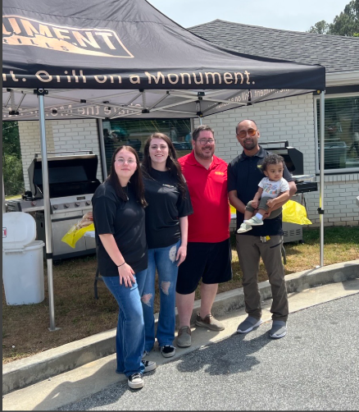

Any chance you can drop the people picture inside below property picture ?
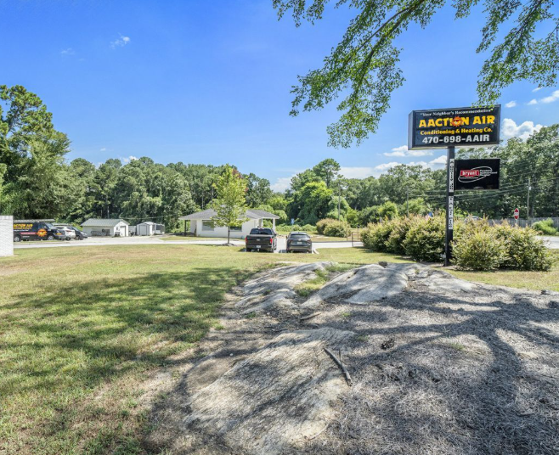
- Trust Badges That Matter – Include CAAG, Greystone, Ruud, American Standard and relevant partners (remove Bryant -BFAD ) add a regular Bryant logo ( Should we add anymore ? ) AprilAire, Honeywell
- 470-698- 2247 number I believe needs to be a tracking number. ( James said this numbers might have to be used in order not to confuse google if he recalled from a meeting >?)
- Add SC mechanical contractors’ number in footer
- Add American Standard – co-op approved to homepage

Premier service plan section ( Home page )
Can we add the customer will receive a computer Analysis report of their system on each visit of service?
- Plan Membership benefits: A) Change two year warranty on replacements to 10 year labor warranty for qualifying systems C) change one year warranty on repairs to a two year. D) Remove the extended warranties on repairs and replacements and add one free diagnostic per plan. E) Combine 10% discount on replacement and accessories to one line item. F) Add, - addition system discounts on service plan
- When I click Join today button. The link is broken ( PSP section)
- John to provide art work for “ club membership PAYS$.. Ask us how ! (2)
- 
- PLAN PRICING -2026 ONLY $99.00 per plan per property ( Unlimited systems)
- When I click the learn more button on home page , I see Charles which is great. However when I scroll further. I see Douglas employee which can be fine. Then I click apply now and it takes me to application form. ( when will the forms work ?)
- Join today tab not working which I would assume is suppose to go to form
Why choose AActionAIr Section
- Call us anytime section, change 24/7 to 7 days a week

- Change Atlanta coupons to FREE diagnostic with repair, 99.00 service plan per property 2026 ONLY, and Free Polarized media air cleaner With purchase of a new system
- Commercial service plans – Let’s add a picture of AAA team, find a relative picture working on commercial. ( maybe from Douglas )
AC Installation page

- Change picture of Tech working on a generator to provide a picture to follow.( Install tab ) ( Use from Douglas Install team. Have a tech in picture ) (3) (lets leave it for now )
- 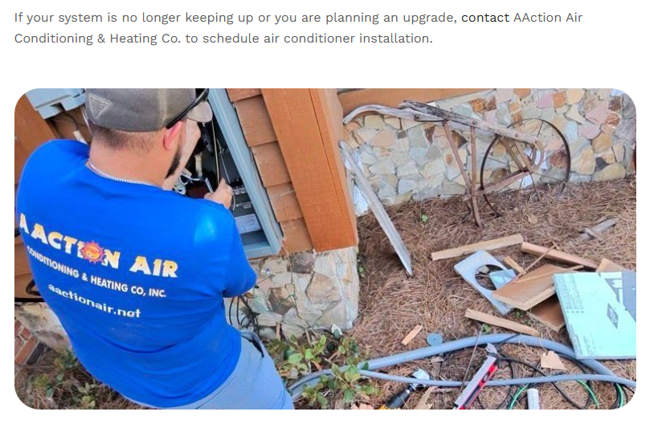
- Change coupon on this page to FREE 10 year labor warranty for qualifying systems
Mini split page
- Change this picture to a Mitsubishi with AAA install team (4)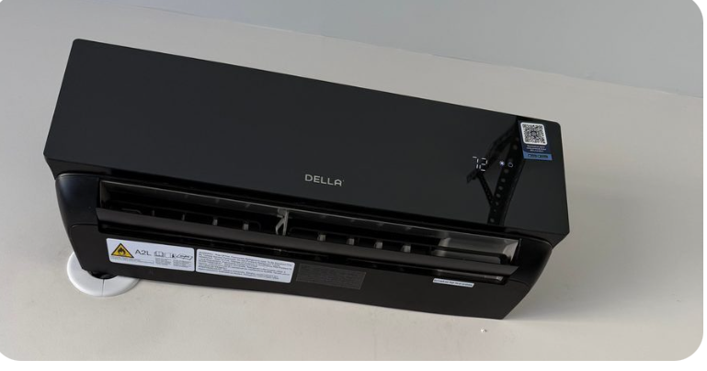 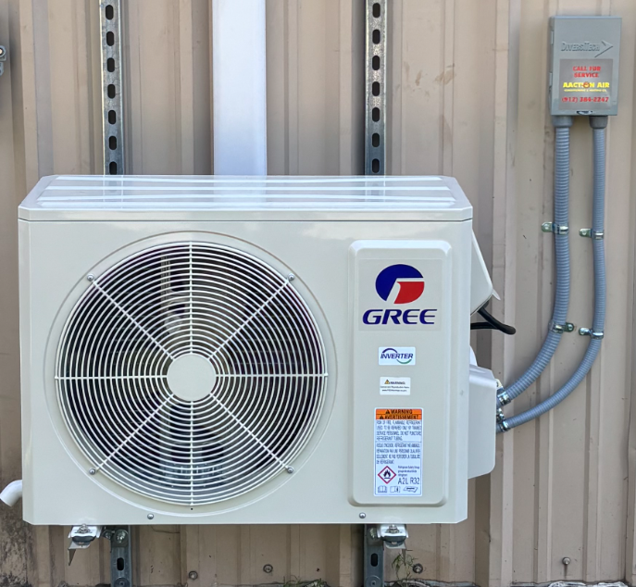
- Lets get a picture of a staff member with tablet on condenser showing measure quick computerized report. Replace this picture (5)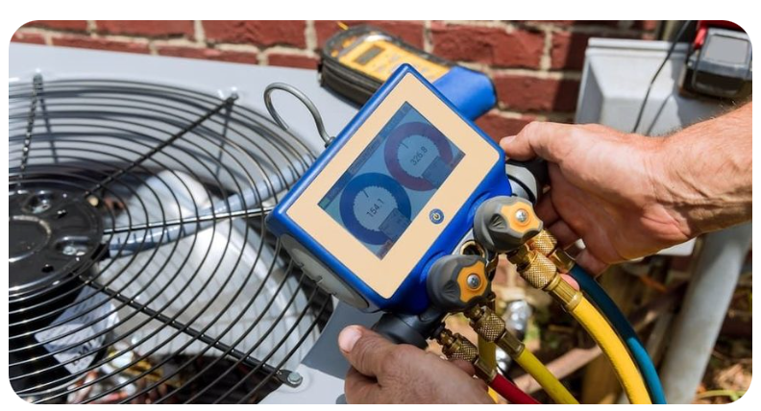
Commercial HVAC page
- Change this coupon to FREE commercial service plan evaluation
OUR service heating heat pump page
- Lets replace the installation coupon to a service coup[on of 75.00 off
Pool heaters section- remove from Atlanta page, add to douglas and savannah
Dual Fuel Hybrid systems
- Maybe we have replace coupons everywhere to set s seeds . lol . If we are going to use . Lets change to the FREE 10 year LABOR warranty for qualifying systems
- Duct work tab. ( Atlanta is the worst when it comes to duct work. This could rally be a market to make money in. They use zones systems. air handlers are in the attic serving 2 to 3 floors with mostly flex system. Lets add a few pictures from the AAA team what a duct system is suppose to look like in a attic and under a house (6)
Zone systems Prominent in Atlanta. Honeywell, EWC- Electronic Wholesalers Controls, Zone first ( Might help to build in content ?)

Dehumidifier and Humidifier section
- Lets get this picture changed to a Aprile Aire whole house dehumidifier installed by the AAA team (7)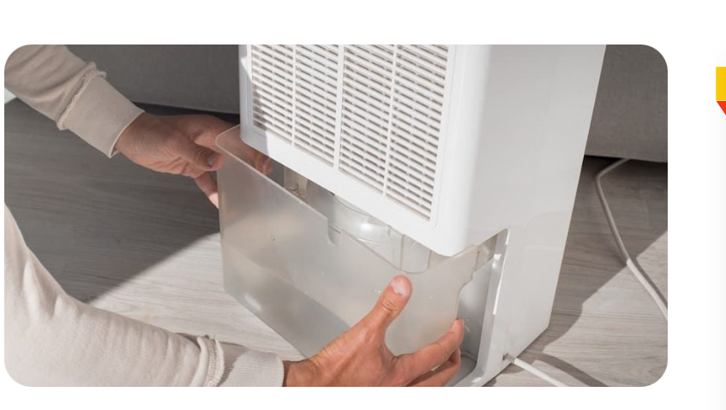 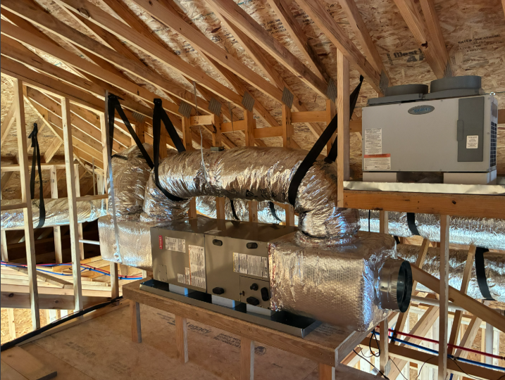
- Use the above picture in the duct waork page as well as the dyhum, please
- 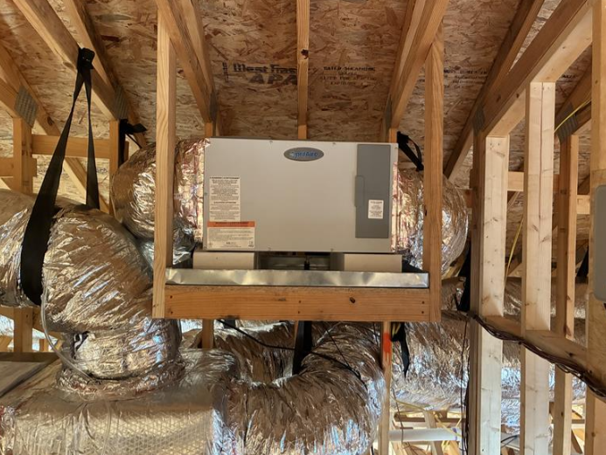
Add picture to the thermostat page
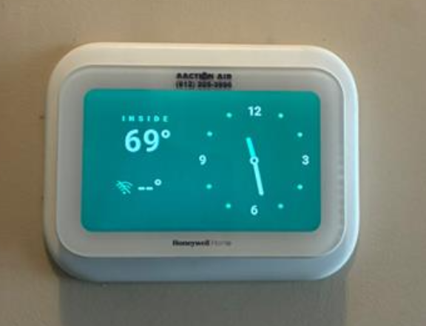
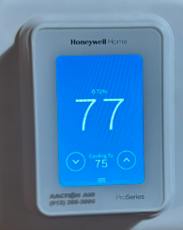 might want to talk about wi-fi stats if it help with remote sensors

Financing apply now button needs to go to the soft pull link see below
OPTIMUS Prequalification

Our work tab , remove following pictures

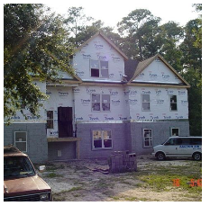
ADD for commercial
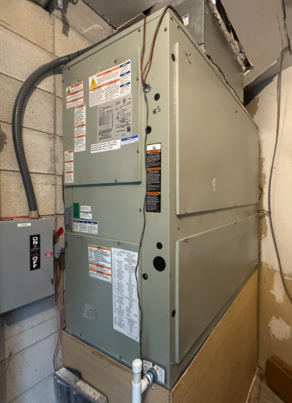
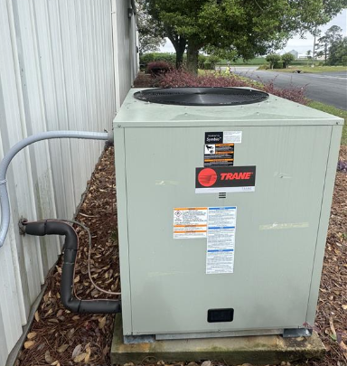
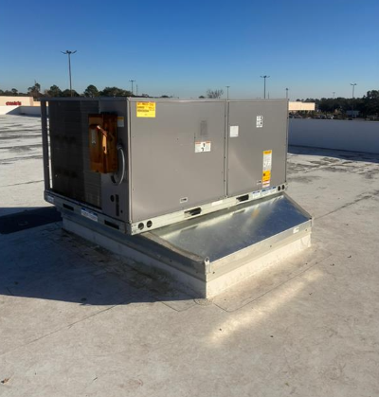
- Remove the American Home shield TAB and all content

ADD in the residential

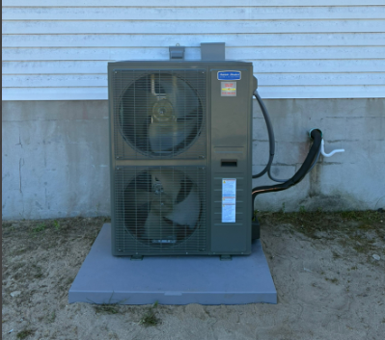

Charles Carroll -BIO ( Add this to our ( Who we are page)

Charles Carroll – Owner, AAction Air Conditioning & Heating
With over 30 years of real-world HVAC experience, Charles Carroll isn’t just another contractor—he’s a trusted expert who’s built his career on hard work, integrity, and delivering results that last.

Raised in a military family and shaped by years of travel across the world and the U.S., Charles brings a disciplined, no-nonsense approach to every job. Since graduating from Chattahoochee Technical College in 1994, he has worked in nearly every corner of the HVAC industry—from hands-on technician and system installs to teaching future professionals and even supporting contractors overseas.

Today, Charles leads AAction Air Conditioning & Heating with a simple mission:
Deliver honest service, top-tier workmanship, and real solutions customers can trust.

✅ Residential & Light Commercial Expertise
✅ Thousands of Systems Repaired & Installed
✅ Straightforward Pricing & No Surprises
✅ Backed by Industry-Leading Warranties

When you call AAction, you’re not getting a sales pitch—you’re getting decades of experience, done right the first time.

Outside of work, Charles is a devoted family man, husband, father, and grandfather. When he’s not helping customers stay comfortable, you’ll find him in the North Georgia mountains enjoying time with his family, fishing, hunting, or just unplugging.

